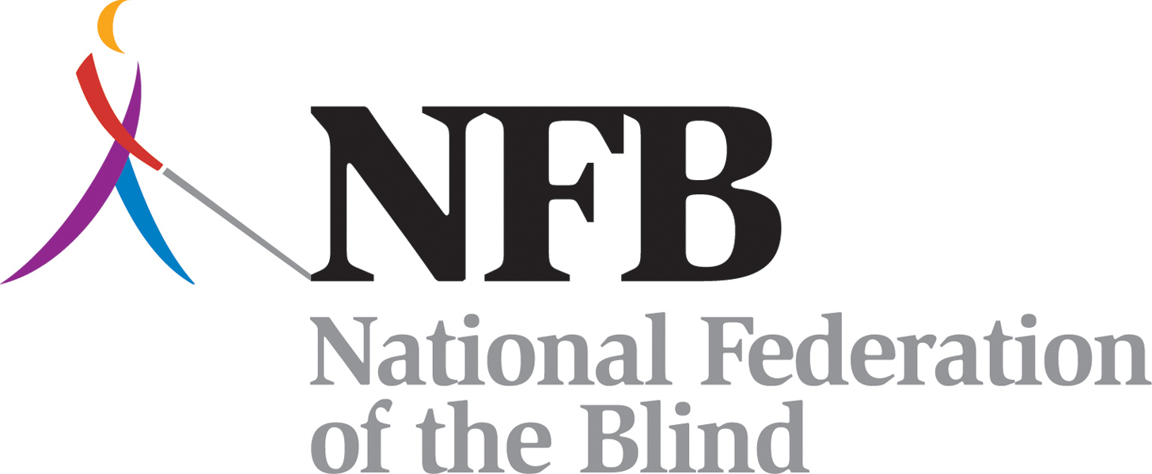

Textbooks on Time Fact Sheet
Prepared by the National Federation of the Blind

Blind and visually impaired children often struggle in school because their books, whether in Braille, audio, or other accessible formats, arrive late. These children must wait, while their classmates proceed with the curriculum. This leads to children who fall behind and, tragically, can result in children who fail because the system has failed them.

What is the law?
There are protections in the law to prevent this situation. The Individuals with Disabilities Education Improvement Act of 2004 (IDEIA 2004), the most recent reauthorization of IDEA, reads:
… To ensure that children with disabilities who need instructional materials in accessible formats are provided those materials in a timely manner, the SEA must ensure that all public agencies take all reasonable steps to provide instructional materials in accessible formats to children with disabilities who need those instructional materials at the same time as other children receive instructional materials.

This means that it is ultimately the responsibility of the state educational agency to provide the blind or visually impaired child's educational materials at the same time as their peers in the classroom.

Who decides what is "timely" and "reasonable?”
Federal regulations leave the interpretation of “timely manner” and “reasonable steps” to individual states. State educational agencies need to focus on another key phrase in the law, "at the same time." It needs to be made clear that lax definitions of "timely" and "reasonable" could be viewed as an effort to circumvent the law.

Who is protected by “at the same time?”
The IDEA, which mandates that children with disabilities receive their school materials at the same time as other children, also provides for the Individualized Education Program (IEP). Blind and visually impaired children with an IEP are thus protected by the "at the same time" clause.

Some blind or visually impaired children do not have an IEP and therefore are not protected under IDEA. However, the right to a "free, appropriate public education" is guaranteed by Section 504 of the Rehabilitation Act, which states that a child with a disability must be provided aids and services to meet his or her individual educational needs. This could be sufficient to guarantee federal protection for receiving textbooks on time.

What materials are covered?
Section 674(e)(3) of IDEA states the following:
(C) PRINT INSTRUCTIONAL MATERIALS- The term 'print instructional materials' means printed textbooks and related printed core materials that are written and published primarily for use in elementary school and secondary school instruction and are required by a State educational agency or local educational agency for use by students in the classroom.

This language raises some questions:
- The Act refers solely to printed materials. What if the print textbook is bundled with computer-based media? If the school has started using computer-based instructional materials rather than printed textbooks, is there language in federal law to guarantee timely access to those materials?
- What counts as "related printed core materials?” Does this cover choices individual teachers may be allowed to make? Does it include teacher-created handouts or handouts copied from accompanying copyrighted materials? Does it cover materials used, for instance, by a music teacher?
- The materials covered are "written and published primarily for use in primary and secondary school settings." Is a novel published for the general public but used in an elementary school classroom not covered? What if the state is not an "adoption state" (see below) and the teacher decides to use a college-level textbook in a high school class?

What formats are available?
The act refers directly to U.S. Copyright Law, which permits the production of Braille, audio, or digital text "exclusively for use by blind or other persons with disabilities." It also includes large print formats when such materials are distributed exclusively for use by blind or other persons with disabilities.

What is NIMAS?
NIMAS—the National Instructional Materials Accessibility Standard—is one part of the textbooks-on-time equation. The language creating NIMAS is a part of the most recent amendments to the IDEA. NIMAS is an electronic file format that is used by K–12 curriculum publishers to produce source files of a given textbook. When textbooks or related materials are adopted by a state or selected by a local authority, these file sets are deposited into the NIMAC (National Instructional Materials Access Center) repository. These files can subsequently be used to produce the textbook in a specialized format—Braille, digital text, large print, or audio—for students with print disabilities.
The NIMAS format is intended to allow timely production of a textbook in an accessible format. NIMAS is not a student-ready file format, nor is it to be used directly by educators. Access to NIMAS textbook file sets is extremely limited in order to protect intellectual property and copyright. The file sets are available to download only by Authorized Users (AUs) designated by each state, and by Alternative Media Producers (AMPs), who have been selected by the AUs. Producers, however, need to be trained in how to turn a NIMAS file set into an accessible textbook.

Currently, NIMAS files can be used to produce books only for K-12 students with “qualifying disabilities.” These are the same qualifications that must be met to access books through the Library of Congress National Library Service for the Blind and Physically Handicapped (NLS). In other words, students who qualify for NLS services through their regional library for the blind automatically meet the disability criteria for receiving materials generated through the NIMAS system.

Only states that choose to opt in to the NIMAS system are eligible to use NIMAS file sets for their students who qualify. At this time, there are states that have opted out of (decided not to join) NIMAS. Although these states cannot access NIMAS file sets, they are not exempt from satisfying the “timely manner,” “reasonable steps,” and “at the same time” requirements.

Implementation of NIMAS: Current Issues
- Some states do not select textbooks at the state level (non-adoption states) or do so only in part. Since textbook file sets are deposited into NIMAC only after a state agency has adopted a given textbook, states that allow textbooks to be selected at the local level may face considerable delay in getting a book produced in an alternative format on time.
- File sets for adopted books are to be deposited into the NIMAC at the time of adoption. However, adoption schedules in some states can be so late in the school year that timely production of a textbook may not be possible.
- NIMAS file sets are only required for textbooks published after July 19, 2006.
- NIMAS file sets are not at this time compatible with Braille Nemeth Code. Resolution of this issue is, however, a priority for educational technology developers.
- NIMAS file sets are not necessarily compatible with the production of tactile graphics, nor are textbook publishers required to include appropriate descriptions of non-text material. Decisions about how to deal with figures—for example, whether or not to provide descriptions or create tactile diagrams—may be left to the Authorized Media Producers. The quality of descriptions or tactile renditions of figures, graphs, and illustrations is entirely in the hands of the AMP, which may not have the necessary expertise to judge how best to make graphical information accessible to blind or visually impaired students.

Your Feedback Can Help!

What can be done on the local level?
- Make sure your state office of education or other authority is aware of the time it takes to produce a textbook in an alternative format.
- Find out if your state is a textbook adoption state. Learn the schedule of adoption cycles, and inform authorities that books adopted late in the school year may not arrive on time in the appropriate alternative format.
- If your state does not adopt textbooks at the state level, the entity selecting books needs to be informed about the difficulty of producing books in an alternative format and that the law requires that books in an alternative format be available on time.
- Become an informed advocate by learning the answers to the following questions:
  - How are books ordered for blind or visually impaired students in your community or local education agency (LEA)?
  - Can the process be monitored?
  - Has the state opted into this process? If not, ask for a reason why and make sure that the system in place is supplying books on time!
  - Are any blind or visually impaired students in the state or school district receiving services via Section 504? If so, are their books and materials arriving on time?
- Make sure that, independent of the method of adoption or selection of textbooks, correct language is present in ordering contracts to ensure that NIMAS file sets will be deposited on or before delivery of the print instructional materials.
- Does the state offer guidelines on how figures, graphics, and diagrams are to be handled, so that blind/visually impaired students do not lose instructional content?

How is the delivery of textbooks working in your community?
The NFB is looking for information and trends that will help determine what actions might be taken to move closer to the goal of textbooks on time. If your state has opted out of NMAC and students are not receiving their books on time, or if your state has opted in and problems persist, please report it to the appropriate state education agency and send a copy to us. Also, if your state or local education agency does an exemplary job of getting educational materials into a student's hands on time, we’d like to hear about your experience. Please send an e-mail to booksontime@nfb.org, or write us at:

National Federation of the Blind
Governmental Affairs
Attention: Textbooks on Time
1800 Johnson Street
Baltimore, MD 21230

For more information, please visit www.nfb.org.

